Oxford City Council (the Council) in exercise of the power under section 59 of the Anti-Social Behaviour, Crime and Policing Act 2014 (the Act), being satisfied that the conditions set out in section 59 of the Act have been met, makes the following order:

- Any person in a public place within Restricted Area 1 shall be in breach of this Order if they, at any time, on any land in the Restricted Area 1:
  - creates, prepares, lights, is in control of or participates in the use of or enjoyment of a fire or barbeque that is not within a marked designated area, unless:

  - they have a reasonable excuse for doing so.

- Any person in a public place within Restricted Area 2 shall be in breach of this Order if they, at any time, on any land in the Restricted Area 2:
  - causes damage to the land; unless:
  - they have a reasonable excuse for doing so; or,
  - the owner, occupier or other person or authority having control of the relevant land has consented or given permission to them to do so.

Definitions

- The Authority means Oxford City Council (the Council).

- Authorised Officer means a police officer, an employee, agent, contractor of the Council or other person who is authorised in writing by the Council.

- Relevant Land means the piece of land in a Restricted Area.

- Restricted Area means the land designated in the Schedule Of Land to this Order.

- The Order applies to all times of day and night.

- This Order comes into force on XXXX and will remain in force for a period of three years from that date.

Penalty

- Any person who, without reasonable excuse fails to comply with this Order shall be guilty of an offence and liable on conviction to a fine not exceeding level 3 on the standard scale.

- A person failing to comply with this Order may be offered a fixed penalty notice. A fixed penalty notice is a notice offering the person to whom it is issued the opportunity of discharging any liability to conviction for the offence by payment of a fixed penalty.

SCHEDULE OF LAND

Restricted Area 1. All areas detailed in yellow on the map below.
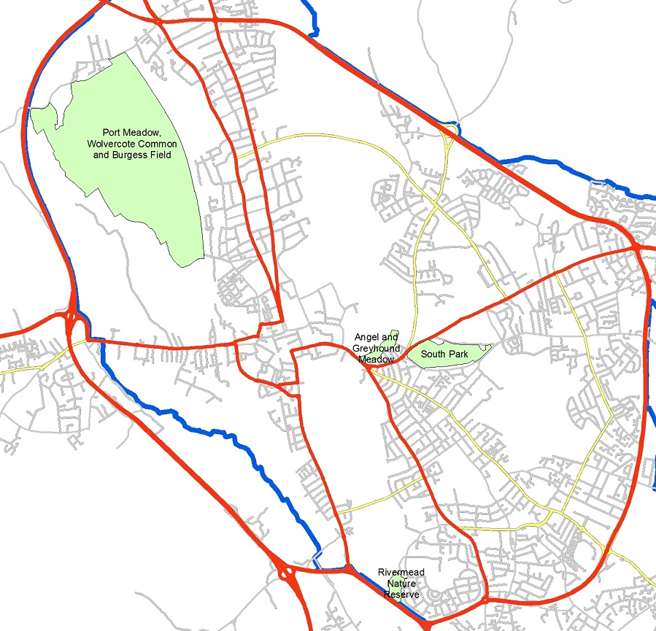

Restricted Area 2. The area labelled Port Meadow, Wolvercote Common and Burgess Field in the map below.

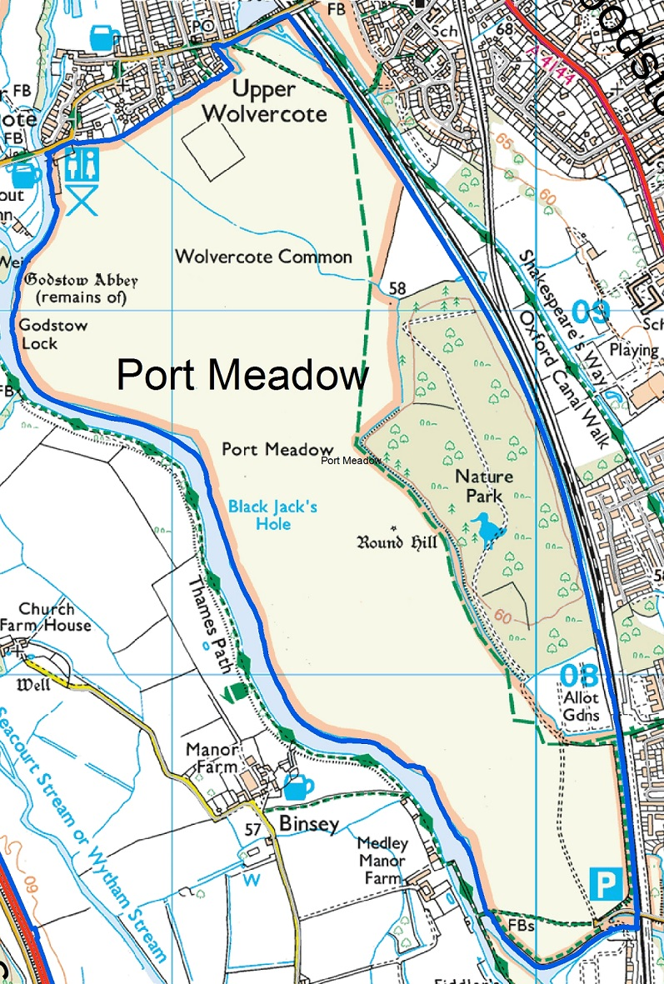
© Crown Copyright and database right 2011. Ordnance Survey 100019348.

CHALLENGING THE VALIDITY OF ORDERS
An interested person may apply to the High Court to question the validity of—
- This Order, or
- A future variation of this Order.
“Interested person” means an individual who lives in the restricted area or who regularly works in or visits that area.
An appeal against this Order or a future variation of this Order may be made to the High Court within six weeks from the date on which the order or variation is made, on the grounds that:

- Oxford City Council did not have power to make the order or variation, or to include particular prohibitions or requirements imposed by the order (or by the order as varied);
- a requirement under Chapter 2 of the Anti-Social Behaviour, Crime and Policing Act 2014 was not complied with in relation to the order or variation.

Date:

Signature:

Position:

